Data Structure In Java

Data structures are fundamental concepts in computer science that allow you to organize, store, and manipulate data efficiently. They provide ways to represent and manage different types of data and enable algorithms to operate on that data effectively. A data structure is not only used for organizing the data. It is also used for processing, retrieving, and storing data.

Branch Of Data Structure:

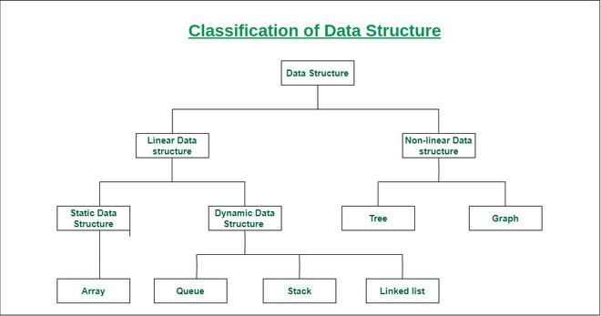

Data structures can be classified based on several criteria, including their organization, behavior, and usage. Here's a classification of data structures based on different aspects:

- Linear Data Structures: In linear data structures, data elements are organized sequentially, and each element has a unique predecessor and successor. Examples include arrays, linked lists, stacks, and queues.
- Static Data Structures: Static data structures have a fixed size that's determined at the time of creation and cannot be easily changed during runtime. Arrays are an example of a static data structure.
- Dynamic Data Structures: Dynamic data structures can change in size during runtime. Linked lists, stacks, and queues can be dynamically resized to accommodate changing data requirements.
- Non-linear Data Structures: Non-linear structures do not have a sequential organization. Elements can have multiple predecessors and successors, forming complex relationships. Examples include trees and graphs.
Introduction Of Array:

Arrays: Arrays are a simple and fundamental data structure that store elements of the same data type in contiguous memory locations. Elements can be accessed using an index, and arrays have constant-time access time for any given element. However, inserting or deleting elements from an array can be inefficient because it may require shifting elements.

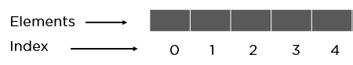

Array Index: In an array, elements are identified by their indexes. Array index starts from 0.
Array element: Elements are items stored in an array and can be accessed by their index.
Array Length: The length of an array is determined by the number of elements it can contain.

Java array declarations.

// The syntax of declaring a static array is:
<data type><variable name>[] =. {<data1>, <data2>,…..<dataN> };

// Example:
int arr[] = { 2, 5, 6, 9, 7, 4, 3 };

class Main {
public static void main(String[] args) {
// create an array
int[] age = {11, 6, 4, 3, 4};
// access each array components
System.out.println("Accessing components of Array:");
System.out.println("First component: " + age[0]);
System.out.println("Second component: " + age[1]);
System.out.println("Third component: " + age[2]);
System.out.println("Fourth component: " + age[3]);
System.out.println("Fifth component: " + age[4]);
}
Output:

Accessing Elements of Array:
First Element: 11
Second Element: 6
Third Element: 4
Fourth Element: 3
Fifth element: 4

Time Complexity: O(n)
Auxiliary Space: O(1)
}

Applications of Array Data Structure:

Here are some common applications of arrays in Java with examples:

1. Storing and Accessing Data:
Arrays are often used to store and retrieve a collection of data elements. For example, you can use an array to store a list of integers:

int[] numbers = {1, 2, 3, 4, 5};

You can access elements using their index, such as `numbers[2]` to access the third element with the value `3`.

2. Iteration:
Arrays are great for iterating over a collection of elements using loops. For instance, you can loop through an array of names:

String[] names = {"Alice", "Bob", "Charlie", "David"};
for (String name : names) {
System.out.println(name);
}

3. Sorting and Searching:
Arrays are commonly used for sorting and searching algorithms. You can sort an array using methods like `Arrays.sort()` and search for elements using linear or binary search.

int[] numbers = {5, 1, 3, 2, 4};
Arrays.sort(numbers); // Sort the array
int index = Arrays.binarySearch(numbers, 3); // Binary search for the value 3

4. Stacks and Queues:
You can implement stack and queue data structures using arrays. For example, to create a simple stack:

int[] stack = new int[10];
int top = -1; // Initialize top pointer
// Push an element onto the stack
stack[++top] = 42;
// Pop an element from the stack
int value = stack[top--];

5. Multi-dimensional Arrays:
Arrays can be used to represent multi-dimensional data structures like matrices. For instance, a 2D array to represent a chessboard:

char[][] chessboard = new char[8][8];
chessboard[0][0] = 'R';
chessboard[7][7] = 'K';

6. Collections of Objects:
Arrays can hold objects of any class type. For example, an array of `Person` objects:

class Person {
String name;
int age;
}

Person[] people = new Person[3];
people[0] = new Person("Alice", 25);
people[1] = new Person("Bob", 30);

7. Dynamic Arrays (ArrayList):
Java provides dynamic arrays through the `ArrayList` class, which is an implementation of a resizable array. It allows you to add and remove elements without worrying about the underlying array size.

import java.util.ArrayList;

ArrayList<Integer> dynamicArray = new ArrayList<>();
dynamicArray.add(1);
dynamicArray.add(2);
dynamicArray.remove(0);

Advantages of Arrays in Java:

1. Fast Access: Array elements can be accessed directly using their index, which allows for fast and constant-time access. This makes arrays efficient when you need to access elements by their position.

2. Memory Efficiency: Arrays are memory-efficient as they store elements in contiguous memory locations. This results in efficient memory usage compared to some other data structures, especially when dealing with primitive data types.

3. Simplicity: Arrays are simple to use and understand, making them a straightforward choice for organizing and manipulating collections of data.

4. Predictable Size: Arrays have a fixed size, which can be an advantage when you have a known number of elements to store, as it prevents accidental resizing or reallocation.

5. Good for Iteration: Arrays are suitable for iterating through elements using loops, which can be helpful for performing various operations on the elements.

Disadvantages of Arrays in Java:

1. Fixed Size: One of the most significant limitations of arrays is their fixed size. Once you declare an array with a specific size, you cannot easily change it. This can lead to wasted memory or not having enough space if the size is not accurately determined at the outset.

2. Inefficient Insertion/Deletion: Inserting or deleting elements within an array can be inefficient. If you insert an element in the middle of an array, you may need to shift all subsequent elements to accommodate the new element, which can be time-consuming, especially in large arrays.

3. Lack of Dynamic Sizing: Unlike some other data structures (e.g., ArrayLists), arrays cannot dynamically resize themselves to accommodate more elements. You must manually create a new, larger array and copy elements if you run out of space.

4. Homogeneous Elements: Arrays require elements of the same data type. This limitation means that you cannot have an array that stores elements of different types without using wrapper classes (e.g., `Object[]`), which can lead to less type safety.

5. Sparse Data: Arrays are not efficient for storing sparse data (data with many gaps or unused elements), as memory is allocated for all elements, even if they are not used.

String Data Structure:

What is String?

A String is seen anywhere and everywhere. Right from when you login onto your device, you enter a String, i.e. your password, name, etc.
In Java, a string is a sequence of characters. For example, "hello" is a string containing a sequence of characters 'h', 'e', 'l', 'l', and 'o'.

String is represented in Various Form:

In Java, strings are represented in memory as instances of the `java.lang.String` class. The `String` class is part of the Java standard library and provides methods and functionality for working with strings. Here's an overview of how strings are represented in memory in Java:

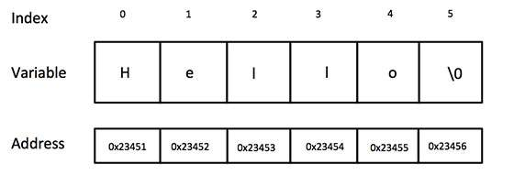

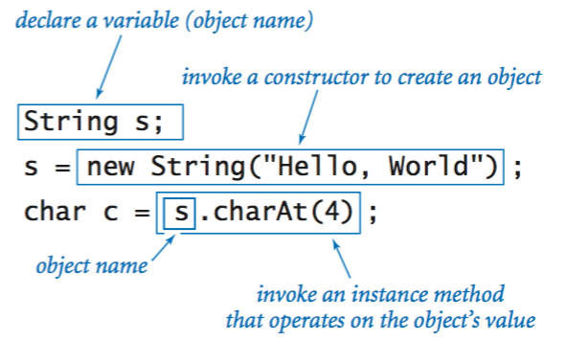

1. String Pool: Java maintains a special pool called the "String pool" or "String constant pool" to store string literals. When you create a string literal (e.g., `"Hello"`), Java checks if it already exists in the pool. If it does, it reuses the existing instance; otherwise, it creates a new one and adds it to the pool. This helps conserve memory by avoiding duplicate string instances with the same value.

String str1 = "Hello"; // Created in the string pool
String str2 = "Hello"; // Reuses the existing instance from the pool

2. Heap Memory: For strings created using the `new` keyword, a new instance is allocated on the heap memory. These strings are not added to the string pool by default, and each `new` instance is unique, even if the content is the same.

String str3 = new String("Hello"); // Created on the heap, not in the string pool

3. Immutable: Strings in Java are immutable, which means their content cannot be changed once they are created. If you want to modify a string, you actually create a new string with the modified content.

String original = "Hello";
String modified = original + ", World"; // Creates a new string with the modified content.

4. Char Array: Internally, the `String` class represents strings as an array of characters (`char[]`). This character array holds the actual characters of the string.

char[] charArray = {'H', 'e', 'l', 'l', 'o'};
String str4 = new String(charArray);

String Declaration in Java:

In Java, you can declare a string variable in several ways, depending on your needs and the context of your program. Here are the most common ways to declare a string in Java:

1. Using String Literal:

You can declare a string variable by directly assigning it a string literal enclosed in double quotation marks.

String name = "John";

This creates a string variable named `name` and initializes it with the value "John."

2. Using the `new` Keyword:

You can create a string object using the `new` keyword, but this approach is less common for strings because strings are immutable, and literals are typically used for efficiency.

String city = new String("New York");

This creates a string object named `city` with the value "New York."

3. Empty String:

You can declare an empty string by assigning an empty string literal to the variable.

String message = "";

This creates an empty string named `message`.

4. Null String:

You can declare a string variable and initialize it with the `null` value, indicating that it doesn't currently reference any string object.

String text = null;

Basic Operations of String:

In Java, you can perform various basic operations on strings using the `java.lang.String` class. Here are some common string operations with examples:

1. String Concatenation:

You can concatenate strings using the `+` operator or the `concat()` method.

String str1 = "Hello";
String str2 = " World";
String result1 = str1 + str2; // Using the + operator
String result2 = str1.concat(str2); // Using the concat() method
System.out.println(result1); // Output: "Hello World"

2. String Length:

To get the length of a string, use the `length()` method.

String text = "Java Programming";
int length = text.length();
System.out.println("Length: " + length); // Output: "Length: 15"

3. Substring Extraction:

You can extract a substring from a string using the `substring()` method.

String text = "Hello, World";
String sub = text.substring(7); // Extracts from index 7 to the end
System.out.println(sub); // Output: "World"

4. String Comparison:

You can compare strings using the `equals()`, `equalsIgnoreCase()`, and `compareTo()` methods.

String str1 = "hello";
String str2 = "Hello";
boolean isEqual = str1.equals(str2); // Case-sensitive comparison
boolean isEqualIgnoreCase = str1.equalsIgnoreCase(str2); // Case-insensitive comparison
int compareResult = str1.compareTo(str2); // Lexicographic comparison

5. Searching in a String:

You can search for substrings within a string using methods like `indexOf()`, `lastIndexOf()`, and `contains()`.

String text = "Java is fun and Java is powerful";
int index = text.indexOf("Java"); // First occurrence of "Java"
int lastIndex = text.lastIndexOf("Java"); // Last occurrence of

boolean containsJava = text.contains("Java"); // Check if "Java" is present

6. Replacing Substrings:

To replace substrings, you can use the `replace()` method.

String text = "Hello, World";
String replaced = text.replace("World", "Universe");
System.out.println(replaced); // Output: "Hello, Universe"

7. Splitting a String:

You can split a string into an array of substrings using the `split()` method.

String text = "apple,banana,cherry";
String[] fruits = text.split(",");
// fruits is now ["apple", "banana", "cherry"]

8. Trimming:

To remove leading and trailing whitespace from a string, use the `trim()` method.

String text = " Hello, World ";
String trimmed = text.trim();
System.out.println(trimmed); // Output: "Hello, World"

Common Example:

public class StringExamples
{
public static void main(String[] args)
{
//Creating Strings:

String str1 = "Hello, World!";
String str2 = new String("Java Strings");

//String Concatenation:
String firstName = "John";
String lastName = "Doe";
String fullName = firstName + " " + lastName; // Concatenation with +
String message = firstName.concat(" ").concat(lastName); // Using concat()

//String Length:
String text = "Java is fun!";
int length = text.length();

//String Comparison:
String str1 = "Hello";
String str2 = "hello";
boolean isEqual = str1.equals(str2); // false
boolean isEqualIgnoreCase = str1.equalsIgnoreCase(str2); // true

//Substring:
String text = "Hello, World!";
String substring = text.substring(7); // "World!"
String part = text.substring(0, 5); // "Hello"

//String Splitting:
String sentence = "Java is a programming language";
String[] words = sentence.split(" "); // ["Java", "is", "a", "programming", "language"]

//String Conversion:
int number = 42;
String strNumber = String.valueOf(number); // "42"

//String Formatting:
int apples = 5;
int oranges = 3;
String result = String.format("I have %d apples and %d oranges", apples, oranges);
// "I have 5 apples and 3 oranges"

//String Methods:
String text = "Java is fun and Java is powerful";
int index = text.indexOf("Java"); // 0 (index of the first occurrence)}
}
Applications of Strings in Java:

1. Text Manipulation: Strings are commonly used to manipulate and process textual data. They are fundamental for working with textual content in Java applications, such as reading and writing files, parsing data, and generating reports.

2. User Input Handling: When dealing with user input, strings are used to capture and store information entered by users through text fields, command-line interfaces, or GUI forms.

3. Communication Protocols: Strings are used to encode and decode messages in communication protocols. For example, in networking applications, strings often represent data that needs to be transmitted between clients and servers.

4. Database Operations: Strings are essential for constructing and executing SQL queries in database operations. They also help in handling data retrieved from database queries.

5. Data Serialization: Strings are commonly employed in data serialization and deserialization, allowing data to be converted to a string format for storage or transmission and then reconstructed from the string.

6. Error Handling and Logging: Strings are used in error messages and log entries to provide context and information about issues that occur in an application.

7. GUI and User Interfaces: In graphical user interfaces (GUIs), strings are used for labels, buttons, menu items, and other UI components that display text to users.

8. Regular Expressions: Strings are extensively used with regular expressions for pattern matching and text searching tasks.

Advantages of Strings in Java:

1. Immutable: Strings in Java are immutable, meaning their content cannot be changed once created. This immutability provides safety and consistency in multithreaded applications.
2. String Pool: Java maintains a string pool, which helps conserve memory by reusing string instances with the same value. This is especially advantageous for frequently used string literals.

3. Wide Range of Methods: The `String` class provides a rich set of methods for string manipulation, making it easy to perform various operations on strings, such as concatenation, substring extraction, and searching.

4. Platform Independence: Java strings are platform-independent, allowing code to work consistently across different operating systems and architectures.

Disadvantages of Strings in Java:

1. Memory Overhead: Strings in Java can consume more memory than primitive data types due to their object-oriented nature and the overhead of the `String` class. This can be a concern in applications that handle large volumes of string data.

2. Performance Overhead: Immutable strings can lead to performance overhead when performing frequent string manipulations. Creating new strings for modifications can be less efficient than mutable alternatives in some cases.

3. String Concatenation: Repeatedly concatenating strings using the `+` operator can result in inefficient string building, as new string objects are created at each step. StringBuilder or StringBuffer can be more efficient for such operations.

4. Null Strings: Handling null strings can be error-prone. Developers need to be cautious about potential null pointer exceptions when working with strings that may be null.

Linked list:

A linked list is a linear data structure used in Java and other programming languages to store and manage a collection of elements dynamically. It consists of nodes, where each node contains both data and a reference (or link) to the next node in the sequence. Linked lists can be used to implement various data structures like stacks, queues, and dynamic lists.

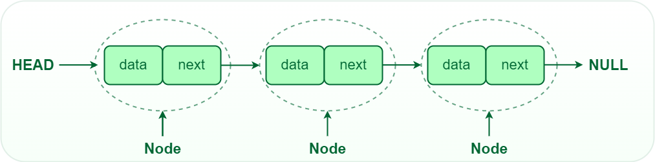

- Node Structure: A node in a linked list typically consists of two components:
- Data: This component holds the actual value or data associated with the node. It can be of any data type, depending on the application's requirements. For example, in a linked list of integers, the data component would be an integer. In a linked list of strings, it would be a string, and so on.
- Next Pointer (or Reference): This component is a reference or pointer that points to the next node in the linked list. It indicates the connection between nodes in the list. In the last node of a singly linked list, this pointer often points to null (or None in Python) to signify the end of the list.
- Head and Tail: The linked list is accessed through the head node, which points to the first node in the list. The last node in the list points to NULL or nullptr, indicating the end of the list. This node is known as the tail node.

Types of linked lists:
- Singly-linked list
- Doubly linked list
- Circular linked list
- Circular doubly linked list

Introduction to Singly Linked List:

Singly Linked List: In a singly linked list, each element (node) contains a data element and a reference (pointer) to the next node in the list. The last node typically points to a null reference, indicating the end of the list.
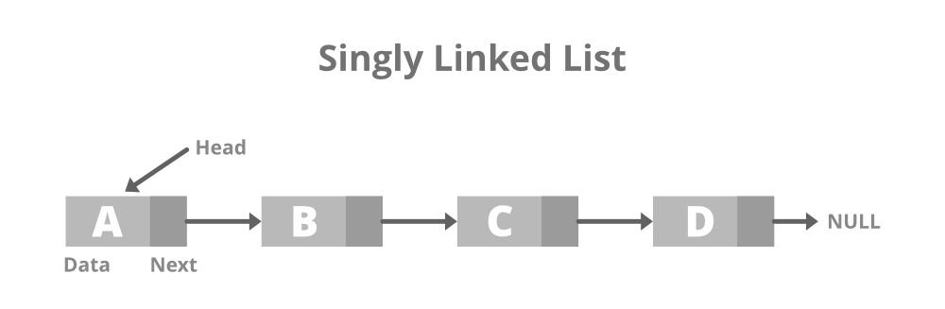

Node representation of a Singly Linked List:

class Node {
int data;
Node next;

Node(int data) {
this.data = data;
this.next = null;
}
}

Fundamental operations performed on Singly Linked list:

1. Creation of a Singly Linked List:

To create a singly linked list, you typically create a `Node` class and a `LinkedList` class that contains the nodes.

class Node {
int data;
Node next;

Node(int data) {
this.data = data;
this.next = null;
}
}

class LinkedList {
Node head;

LinkedList() {
head = null;
}
}

2. Insertion at the Beginning:

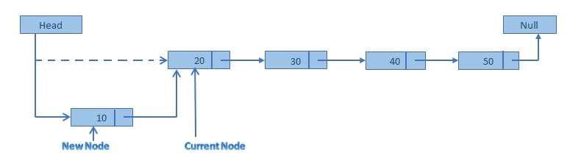

- Create a new node with the data you want to insert.
- Update the new node's next reference to point to the current head of the list.
- Update the head of the list to be the new node.

public void insertAtBeginning(int data) {
// Create a new node
Node newNode = new Node(data);

// Update the new node's next reference to point to the current head
newNode.next = head;

// Update the head to be the new node
head = newNode;
}
Example:
Data->2 -> 3
LinkedList list = new LinkedList();
list. insertAtBeginning (1);
// Resulting list: 1 -> 2 -> 3

3. Insertion at the End:

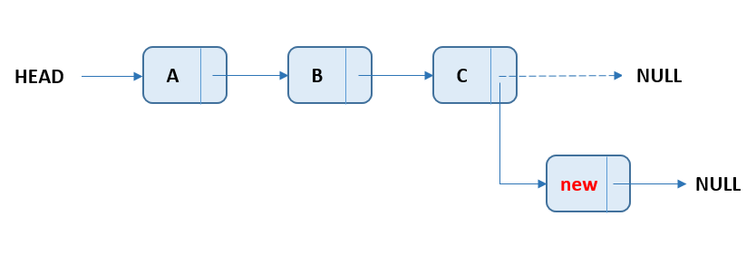

- Create a new node with the data you want to insert.
- Traverse the list from the head node to the last node, maintaining two pointers: one to the current node and another to the previous node.
- Once you reach the last node (i.e., the node whose next reference is null), update the next reference of this last node to point to the new node.
- Make sure to update the new node's next reference to null, as it's now the last node in the list.

public void insertAtEnd(int data) {
Node newNode = new Node(data);

// If the list is empty, make the new node the head
if (head == null) {
head = newNode;
} else {
Node current = head;

// Traverse to the last node
while (current.next != null) {
current = current.next;
}

// Update the last node's next reference to point to the new node
current.next = newNode;
}
}
Example:
Data-> 1 -> 2
LinkedList list = new LinkedList();
list. insertAtEnd (3);
// Resulting list: 1 -> 2 -> 3

4. Deletion by Value:

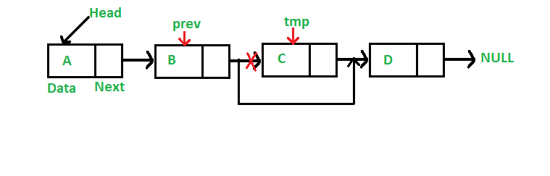

- Identify the node to be deleted.
- Locate the node immediately before the node to be deleted.
- Update the next reference of the previous node to skip the node to be deleted.
- Dispose of the deleted node (optional).

public void delete(int value) {
if (head == null) {
System.out.println("Singly linked list is empty. Nothing to delete.");
return;
}

Node current = head;
Node prev = null;
boolean found = false;

// Traverse the singly linked list to find the node to delete
while (current != null) {
if (current.data == value) {
found = true;
break;
}
prev = current;
current = current.next;
}

// If the node to delete is found
if (found) {
// If it's the head node, update the head reference
if (current == head) {
head = current.next;
} else {
// Update the previous node's next reference to skip the node to delete
prev.next = current.next;
}

// Optional: Dispose of the deleted node
current = null;
} else {
System.out.println("Node with value " + value + " not found.");
}
}

Example:
Data-> 1 -> 3->2
list. delete (2);

LinkedList list = new LinkedList();
list.append(1);
list.append(2);
list.append(3);
list.delete(2);
// Resulting list: 1 -> 3

5. Searching for a Value:

You can search for a value in the linked list by traversing the list and comparing each node's data.

public boolean search(int data) {
Node current = head;
while (current != null) {
if (current.data == data) {
return true;
}
current = current.next;
}
return false;
}

Example:

LinkedList list = new LinkedList();
list.append(1);
list.append(2);
list.append(3);
boolean found = list.search(2); // true

6. Displaying the Linked List:

Displaying the linked list involves traversing it and printing the data of each node.

public void display() {
Node current = head;
while (current != null) {
System.out.print(current.data + " -> ");
current = current.next;
}
System.out.println("null");
}

Example:

LinkedList list = new LinkedList();
list.append(1);
list.append(2);
list.append(3);
list.display(); // Output: 1 -> 2 -> 3 -> null

Singly Linked List Time Complexity:

Operation | Time Complexity
Insertion at the beginning | O(1)
Insertion at the end | O(n)
Insertion at a specific position (with known pointer) | O(1)
Deletion at the beginning | O(1)
Deletion at the end | O(n)
Deletion at a specific position (with known pointer) | O(1)
Searching for an element | O(n)
Accessing an element by index | O(n)
Traversing the list | O(n)
Reversing the list | O(n)
Finding the length | O(n)

All basic operation Java in one Example:

class Node {
int data;
Node next;

Node(int data) {
this.data = data;
this.next = null;
}
}

class LinkedList {
Node head;

LinkedList() {
head = null;
}

// Insertion at the end of the linked list
public void append(int data) {
Node newNode = new Node(data);
if (head == null) {
head = newNode;
} else {
Node current = head;
while (current.next != null) {
current = current.next;
}
current.next = newNode;
}
}

// Insertion at the beginning of the linked list
public void prepend(int data) {
Node newNode = new Node(data);
newNode.next = head;
head = newNode;
}

// Deletion by value
public void delete(int data) {
if (head == null) {
return;
}
if (head.data == data) {
head = head.next;
return;
}
Node current = head;
while (current.next != null) {
if (current.next.data == data) {
current.next = current.next.next;
return;
}
current = current.next;
}
}

// Search for a value in the linked list
public boolean search(int data) {
Node current = head;
while (current != null) {
if (current.data == data) {
return true;
}
current = current.next;
}
return false;
}

// Display the linked list
public void display() {
Node current = head;
while (current != null) {
System.out.print(current.data + " -> ");
current = current.next;
}
System.out.println("null");
}
}
public class Main {
public static void main(String[] args) {
LinkedList list = new LinkedList();

list.append(1);
list.append(2);
list.append(3);
list.prepend(0);

System.out.println("Linked List:");
list.display();

System.out.println("Search for 2: " + list.search(2));

list.delete(2);

System.out.println("Linked List after deleting 2:");
list.display();
}
}

Applications Of Singly Linked List:

1. Dynamic Data Storage: Singly linked lists are useful when you need to store and manage a collection of data elements that can grow or shrink dynamically.

2. Implementing Stacks and Queues: Singly linked lists can be used to implement common data structures like stacks and queues, where elements are added and removed from one end (the head or tail) of the list.

3. Undo/Redo Functionality: Singly linked lists can be used to implement undo and redo functionality in applications by maintaining a history of states or actions.

4. Symbol Tables: They can be used to implement symbol tables in compilers or interpreters for efficient variable and function name lookup.

5. Music and Video Playlists: Singly linked lists can represent playlists, where each node represents a song or video, and the next node points to the next item in the playlist.

6. Navigation in Web Browsers: Browsers use linked lists for forward and backward navigation through the browsing history.

Advantages Of Singly Linked List:

1. Dynamic Size: Singly linked lists can grow or shrink in size during runtime, making them flexible for managing data of unknown or varying size.

2. Efficient Insertions and Deletions: Insertions and deletions at the beginning of the list (head) are very efficient, as they require updating just a few references.

3. Memory Efficiency: Singly linked lists use memory efficiently because they allocate memory for each node only as needed, unlike arrays which often need to allocate a fixed block of memory.

4. Easy Implementation: Implementing singly linked lists is relatively straightforward, making them a good choice for learning data structures.

5. Traversal: Traversing a singly linked list is simple, as each node points to the next one, allowing you to easily iterate through the list.

Disadvantages Of Singly Linked List:

1. Lack of Random Access: Unlike arrays, singly linked lists do not support constant-time random access to elements. To access an element, you have to start from the head and traverse the list, which can be inefficient for large lists.

2. Extra Memory Usage: Each node in a singly linked list requires additional memory to store the reference to the next node, which can result in higher memory usage compared to arrays.

3. Backward Traversal: Singly linked lists do not support efficient backward traversal. To traverse the list in reverse, you would need to implement a doubly linked list or use additional data structures.

4. Complexity for Some Operations: Certain operations, such as finding the kth element or merging two singly linked lists in a specific order, can be more complex and less efficient than with other data structures.

5. No O(1) Last Element Access: Unlike doubly linked lists, singly linked lists do not have a reference to the last element, so accessing the last element requires traversing the entire list.

Introduction to Doubly Linked List:

A doubly linked list is a data structure in which each node contains a data element and two references, one to the previous node and one to the next node in the sequence. It contains three parts of data, a pointer to the next node, and a pointer to the previous node.

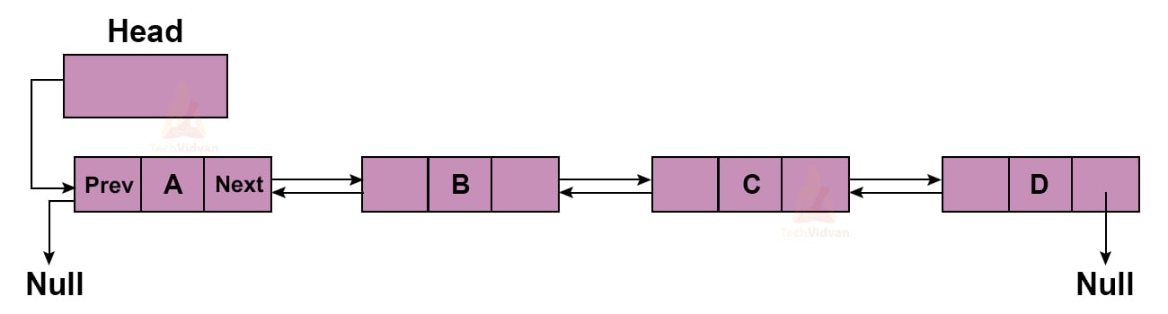

Node representation of a Doubly Linked List:

class Node {
int data;
Node next;
Node prev;

Node(int data) {
this.data = data;
this.next = null;
this.prev = null;
}
}

Fundamental operations performed on Doubly Linked list:

1. Creation of a Doubly Linked List:

To create a doubly linked list, you'll need a `Node` class representing individual elements (nodes) and a `DoublyLinkedList` class to manage the list.

class Node {
int data;
Node prev;
Node next;

Node(int data) {
this.data = data;
this.prev = null;
this.next = null;
}
}

class DoublyLinkedList {
Node head;
Node tail;

DoublyLinkedList() {
head = null;
tail = null;
}
}

2. Insertion at the Beginning:

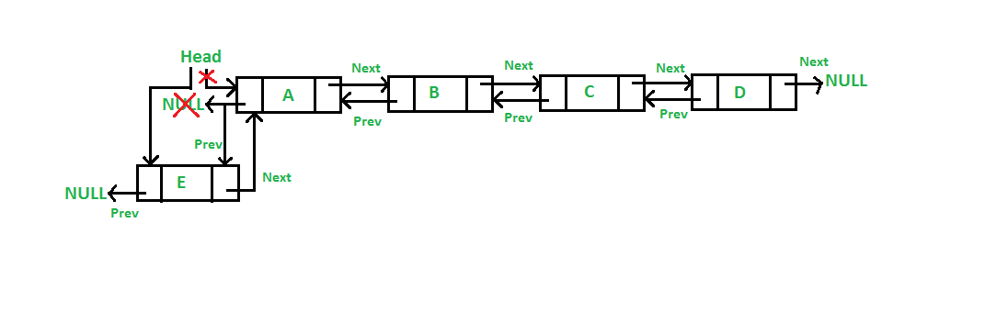

- Create a new node with the data you want to insert.
- Set the next reference of the new node to the current head of the list.
- Set the previous reference of the new node to null, as it will be the new head.
- If the current head is not null, set the previous reference of the current head to point to the new node.
- Update the head of the list to be the new node.

public void insertAtBeginning(int data) {
// Create a new node
Node newNode = new Node(data);

// Set the next reference of the new node to the current head
newNode.next = head;

// Set the previous reference of the new node to null, as it's the new head
newNode.previous = null;

// If the current head is not null, update its previous reference to the new node
if (head != null) {
head.previous = newNode;
}

// Update the head of the list to be the new node
head = newNode;
}

Example:
Data-> 2 <-> 3
DoublyLinkedList list = new DoublyLinkedList();

list.insertAtBeginning (1);

// Resulting list: 1 <-> 2 <-> 3

3. Insertion at the End:

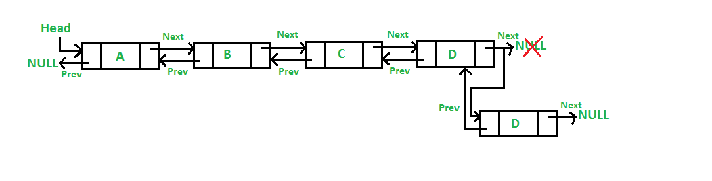

- Create a new node with the data you want to insert.
- Set the next pointer of the new node to null because it will be the last node.
- Set the prev pointer of the new node to point to the current last node.
- Update the next pointer of the current last node to point to the new node.
- Update the last node pointer to be the new node.
{
private Node head;
private Node tail;

public DoublyLinkedList() {
head = null;
tail = null;
}

// Function to insert a node at the end of the doubly linked list
public void insertAtEnd(int data) {
Node newNode = new Node(data);

if (tail == null) {
// If the list is empty, make the new node both the head and tail
head = newNode;
tail = newNode;
} else {
// Update the new node's previous pointer to the current tail
newNode.prev = tail;

// Update the current tail's next pointer to the new node
tail.next = newNode;

// Update the tail pointer to the new node
tail = newNode;
}
}
}

Example:
Data-> 1 <-> 2
DoublyLinkedList list = new DoublyLinkedList();

list. insertAtEnd (3);
// Resulting list: 1 <-> 2 <-> 3

4. Deletion by Value:

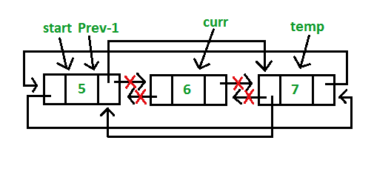

Identify the Node to be Deleted:
- Traverse the list from the head or tail to find the node you want to delete. You may search by value or by position, depending on your requirements.
Update Pointers:
- Once you've identified the node to delete, update the next pointer of the previous node to skip the node to be deleted.
- Update the prev pointer of the next node to skip the node to be deleted.
Dispose of the Deleted Node (Optional):
- If you want to free up memory, you can dispose of the node that you're deleting.

public class DoublyLinkedList {
static class Node {
int data;
Node prev;
Node next;

Node(int data) {
this.data = data;
this.prev = null;
this.next = null;
}
}

private Node head;
private Node tail;

public DoublyLinkedList() {
head = null;
tail = null;
}

// Function to delete a node with a specific value from the doubly linked list
public void delete(int value) {
if (head == null) {
System.out.println("Doubly linked list is empty. Nothing to delete.");
return;
}

Node current = head;

// Traverse the doubly linked list to find the node to delete
while (current != null) {
if (current.data == value) {
// Update the pointers of the adjacent nodes
if (current.prev != null) {
current.prev.next = current.next;
} else {
// If the node to delete is the head node, update the head
head = current.next;
}

if (current.next != null) {
current.next.prev = current.prev;
} else {
// If the node to delete is the tail node, update the tail
tail = current.prev;
}

// Optional: Dispose of the deleted node to free up memory
current = null;
return;
}
current = current.next;
}

System.out.println("Node with value " + value + " not found.");
}

Example:
Data-> 1 <-> 3<->2
DoublyLinkedList list = new DoublyLinkedList();
list.append(1);
list.append(2);
list.append(3);
list.delete(2);
// Resulting list: 1 <-> 3

5. Traversal and Display:

You can traverse and display the doubly linked list in both forward and backward directions.

public void displayForward() {
Node current = head;
while (current != null) {
System.out.print(current.data + " <-> ");
current = current.next;
}
System.out.println("null");
}

public void displayBackward() {
Node current = tail;
while (current != null) {
System.out.print(current.data + " <-> ");
current = current.prev;
}
System.out.println("null");
}

Example:

DoublyLinkedList list = new DoublyLinkedList();
list.append(1);
list.append(2);
list.append(3);
list.displayForward(); // Output: 1 <-> 2 <-> 3 <-> null
list.displayBackward(); // Output: 3 <-> 2 <-> 1 <-> null

Doubly Linked List Time Complexity:

Operation | Time Complexity
Insertion at the beginning | O(1)
Insertion at the end | O(1)
Insertion at a specific position (with known pointer) | O(1)
Deletion at the beginning | O(1)
Deletion at the end | O(1)
Deletion at a specific position (with known pointer) | O(1)
Searching for an element | O(n)
Accessing an element by index | O(n)
Traversing the list | O(n)
Reversing the list | O(n)
Finding the length | O(n)

Applications Of Doubly Linked List:

1. Text Editors: Text editors often use doubly linked lists to implement their undo and redo functionality. Each node in the list represents a state of the document, and users can navigate through the history of edits in both directions.

2. Browser History: Web browsers use doubly linked lists to maintain a history of visited web pages. Users can navigate backward and forward through their browsing history efficiently.

3. Music Player Playlist: A playlist in a music player can be implemented using a doubly linked list. Users can move forward and backward through the playlist, add songs at the beginning or end, and remove songs efficiently.

4. Task Management: To implement task management applications or to-do lists, doubly linked lists can be used to represent tasks. Users can easily add, delete, and navigate through tasks in both directions.

5. Memory Management: Doubly linked lists can be used in memory management systems to maintain a list of free memory blocks. When allocating or deallocating memory, it's crucial to efficiently update the list of available memory blocks.

6. Caching: In cache management, a doubly linked list can be used to maintain a list of cached items. Items can be added and removed from the cache, and the most recently used items can be efficiently managed at the front of the list.

7. Data Structures: Doubly linked lists are also used as a building block for other data structures like deque (double-ended queue) and various types of advanced linked list structures.

8. LRU (Least Recently Used) Cache: In systems where you need to maintain a cache with a limited capacity, a doubly linked list can be used to implement an LRU cache. The least recently used item can be easily identified and removed when the cache is full.

9. Deque (Double-Ended Queue): Deques are a data structure that allows insertion and removal of elements from both ends. A doubly linked list can be used to implement a deque efficiently.

10. Simulation and Modeling: In simulations and modeling scenarios, you might use doubly linked lists to represent various elements or entities in a system. The ability to traverse and manipulate elements bidirectionally can be valuable for modeling complex systems.

Advantages of Doubly Linked Lists in Java:

1. Bidirectional Traversal: Unlike singly linked lists, doubly linked lists allow for both forward and backward traversal. This makes it easier to navigate the list in both directions, which can be useful in certain algorithms and operations.

2. Insertion and Deletion: Insertion and deletion of elements at the beginning or end of the list can be done in O(1) time complexity, provided you have references to the first and last nodes. In contrast, inserting or deleting elements at the beginning of an array or singly linked list requires shifting elements, which takes O(n) time.

3. Dynamic Size: Doubly linked lists can dynamically grow and shrink in size without wasting memory. Elements can be added or removed without the need for resizing operations, which are common in arrays.

4. Efficient Insertion/Deletion in the Middle: Inserting or deleting elements in the middle of a doubly linked list is relatively efficient compared to arrays, where it involves shifting elements.

Disadvantages of Doubly Linked Lists in Java:

1. Memory Overhead: Each node in a doubly linked list requires extra memory for storing two references (pointers) - one for the previous node and another for the next node. This additional memory overhead can make doubly linked lists less memory-efficient compared to arrays or singly linked lists.

2. Complexity: Managing the links (pointers) between nodes in a doubly linked list can be more complex and error-prone than managing a singly linked list. You need to update multiple references when inserting or deleting nodes.

3. Slower Access Time: Accessing an element at a specific index in a doubly linked list generally takes O(n) time since you may need to traverse from either the beginning or end to reach the desired element. In contrast, arrays provide O(1) constant-time access to elements at a specific index.

4. Potential for Inefficient Iteration: Although doubly linked lists support bidirectional traversal, the constant overhead of following pointers to access elements can make iterating through the list slower compared to arrays.

Introduction to Circular Linked List:

A circular linked list is similar to a singly or doubly linked list, but the last node's reference points back to the first node (in the case of a singly circular linked list) or the previous node points to the last node (in the case of a doubly circular linked list).

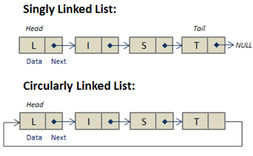

Node representation of a Circular Linked List:

public class Node {
int data;
Node next;

public Node(int data) {
this.data = data;
this.next = null;
}
}

Various operations on a circular linked list:

1. Node Class:

First, create a class to represent the nodes in the circular linked list.

class Node {
int data;
Node next;

public Node(int data) {
this.data = data;
this.next = null;
}
}

2. Insertion at the Beginning:

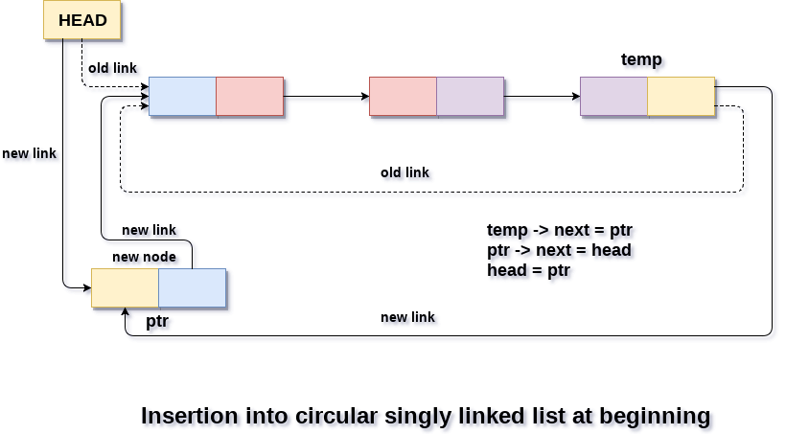

- Create a new node with the given data.
- Check if the list is empty. If it is, set the new node as the head and make it point to itself (circular reference).
- If the list is not empty, set the next of the new node to point to the current head of the list.
- Update the head to point to the new node.
- Update the next of the last node to point to the new head to maintain the circular structure.

class CircularLinkedList {
Node head;

public CircularLinkedList() {
head = null;
}

// Method to insert a node at the beginning
public void insertAtBeginning(int data) {
Node newNode = new Node(data);

if (head == null) {
// If the list is empty, set the new node as the head
head = newNode;
newNode.next = head; // Make it circular
} else {
// If the list is not empty
Node last = head;
while (last.next != head) {
last = last.next;
}
newNode.next = head; // New node points to the current head
head = newNode; // Update the head
last.next = head; // Update the last node's next to point to the new head
}
}

3. Insertion at the End:

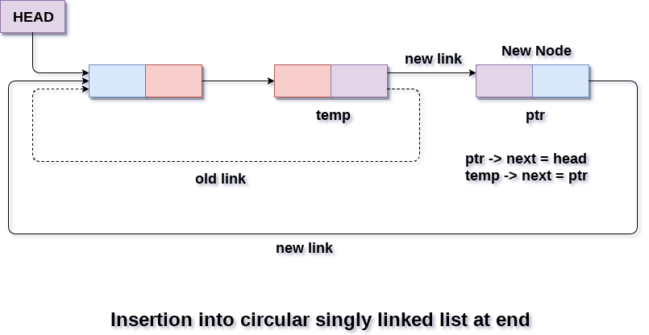

To insert a node at the end of the circular linked list, you need to update the `next` pointer of the last node to point to the new node, and then update the `next` pointer of the new node to point back to the head.

public void insertAtEnd(int data) {
Node newNode = new Node(data);

if (head == null) {
newNode.next = newNode; // Make it point to itself if it's the first node.
head = newNode;
} else {
Node current = head;
while (current.next != head) {
current = current.next;
}
current.next = newNode;
newNode.next = head;
}
}

4. Deletion:
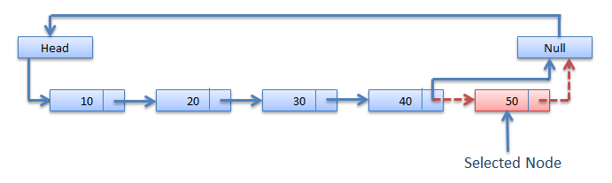

To delete a node from a circular linked list, you need to find the node to delete and update the `next` pointer of the previous node to bypass the node to be deleted.

static Node deleteNode(Node head, int key)
{
if (head == null)
return null;
int flag = 0;
// Find the required node
Node curr = head, prev = new Node();
while (curr.data != key) {
if (curr.next == head) {
System.out.printf(
"Given node is not found in the list!!!\n");
flag = 1;
break;
}

prev = curr;
curr = curr.next;
}

// Check if the element is not present in the list
if (flag == 1)
return head;

// Check if node is only node
if (curr == head && curr.next == head) {
head = null;
return head;
}

// If more than one node, check if
// it is first node
if (curr == head) {
prev = head;
while (prev.next != head)
prev = prev.next;
head = curr.next;
prev.next = head;
}

// check if node is last node
else if (curr.next == head) {
prev.next = head;
}
else {
prev.next = curr.next;
}
return head;
}

5. Traversal:

To traverse a circular linked list, you can start at the head node and iterate until you reach the head node again.

public void display() {
if (head == null) {
return; // Empty list, nothing to display.
}

Node current = head;

do {
System.out.print(current.data + " ");
current = current.next;
} while (current != head);
}

Now, you can create an instance of the circular linked list and perform these operations as needed:

public class CircularLinkedList {
private Node head;

// Insertion and other methods as described above...

public static void main(String[] args) {
CircularLinkedList circularList = new CircularLinkedList();

circularList.insertAtEnd(1);
circularList.insertAtBeginning(2);
circularList.insertAtEnd(3);
circularList.insertAtBeginning(4);

circularList.display(); // Output: 4 2 1 3

circularList.delete(2);
circularList.display(); // Output: 4 1 3
}
}

Circular Linked List Time Complexity:

Operation | Time Complexity | Explanation
Insertion (at front) | O(1) | Inserting a node at the beginning of the list.
Insertion (at end) | O(1) | Inserting a node at the end of the list (if you have a reference to the last node).
Insertion (at position) | O(n) | Inserting a node at a specific position, where 'n' is the position index.
Deletion (at front) | O(1) | Deleting the first node in the list.
Deletion (at end) | O(n) | Deleting the last node in the list (if you don't have a reference to the last node).
Deletion (at position) | O(n) | Deleting a node at a specific position, where 'n' is the position index.
Searching | O(n) | Searching for an element in the list (worst-case scenario where the element is not found).
Traversal | O(n) | Visiting all nodes in the list, typically required for various operations.
Finding Length | O(n) | Counting the number of nodes in the list by traversing it.
Access (by index) | O(n) | Accessing a node at a specific index in the list.

Applications of Circular Linked Lists in Java:

1. Implementing a Circular Buffer: Circular linked lists can be used to implement a circular buffer, which is a data structure often used in streaming and buffering applications where data continuously cycles through a fixed-size buffer.

2. Round Robin Scheduling: In operating systems, circular linked lists can be used for implementing round-robin scheduling algorithms, where each process is assigned a time slice, and the scheduler cycles through them.

3. Circular Lists of Players in Games: In game development, circular linked lists can be employed to represent a list of players or entities where the last player/entity is connected to the first, creating a looping structure.

4. Playlist Management in Music Apps: Circular linked lists can be used to manage playlists in music applications, allowing continuous looping of songs.

Advantages of Circular Linked Lists in Java:

1. Efficient Insertion and Deletion at Both Ends: Circular linked lists allow for efficient insertion and deletion at both the front and the end of the list, as you only need to update a few references, unlike arrays or other data structures.

2. Looping Behavior: Their circular nature makes them suitable for applications where data needs to loop or cycle continuously.

3. No Fixed Size: Unlike arrays, circular linked lists can dynamically grow or shrink as needed, making them flexible in managing data.

4. Easy Implementation: Implementing circular linked lists in Java is relatively straightforward, and they can be useful in scenarios where a circular data structure fits naturally.

Disadvantages of Circular Linked Lists in Java:

1. Complex Traversal: Traversing a circular linked list can be more complex than traversing a simple linked list because you need to check for the loop condition to avoid infinite loops.

2. Additional Overhead: Maintaining a circular reference between the last and first nodes can add a bit of overhead in terms of memory and complexity compared to a simple singly linked list.

3. Not Suitable for Random Access: If you need random access to elements by index, a circular linked list is not the best choice because accessing elements by index requires traversing the list, which can be slow for large lists.

4. Debugging Complexity: Debugging issues in circular linked lists, such as circular references or infinite loops, can be more challenging compared to other data structures.

Introduction to Stack Data Structure:

A stack is a linear data structure that follows the Last-In-First-Out (LIFO) principle, meaning that the most recently added element is the first one to be removed. In Java, you can implement a stack using various data structures, such as arrays or linked lists.

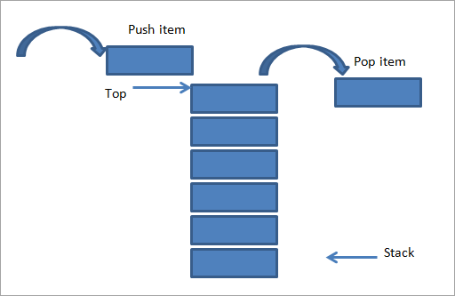

LIFO stands for "Last In, First Out," and it is a fundamental principle in the behaviour of a stack data structure. In a LIFO data structure like a stack, the last element that is added (pushed) onto the stack is the first one to be removed (popped) from the stack. Here's how the LIFO principle works in a stack.

Basic Operations on Stack in Java:

- Push Operation (Addition): When you push (add) an element onto a stack, it becomes the new top element. Subsequent pushes will continue to replace the top element. The last element pushed onto the stack will be at the top.
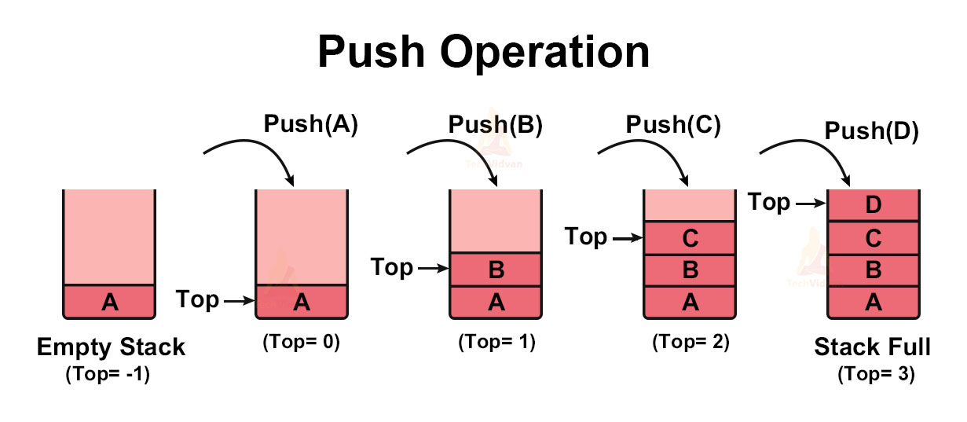

Stack<Integer> stack = new Stack<>();
stack.push(10);
stack.push(20);
stack.push(30);

- Pop Operation (Removal): When you pop (remove) an element from a stack, it removes the top element. You cannot directly access or remove elements from the middle or bottom of the stack; you must remove the top element first.
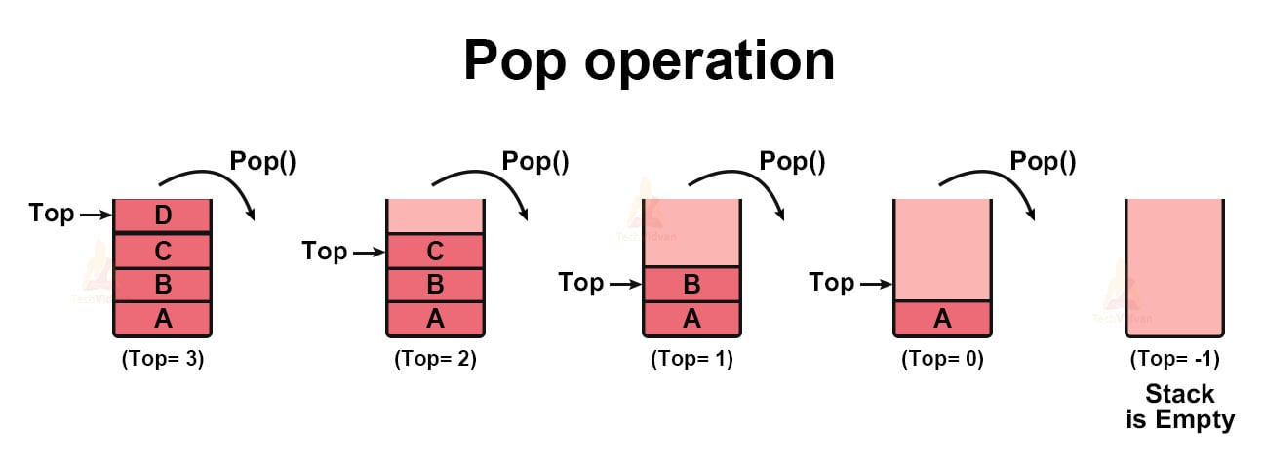

Stack<Integer> stack = new Stack<>();
int poppedElement = stack.pop();

- Peek at the Top Element: To view the top element of the stack without removing it, use the peek method.
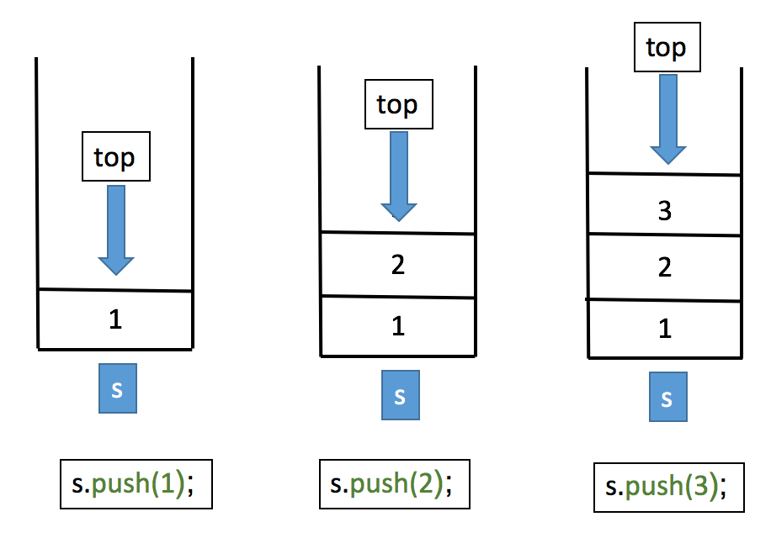

Stack<Integer> stack = new Stack<>();
int topElement = stack.peek();

- Check if the Stack is Empty: You can check if the stack is empty using the isEmpty method.
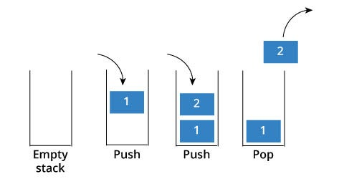

Stack<Integer> stack = new Stack<>();
boolean isEmpty = stack.isEmpty();

- Get the Size of the Stack: To get the number of elements in the stack, use the size method.

Stack<Integer> stack = new Stack<>();
int stackSize = stack.size();

- Iterate Over the Stack: You can iterate over the elements of the stack using a loop or a for-each loop.

for (Integer element : stack) {
System.out.println(element);
}

Implementation Of a Stack Data Structure in Java using a Linked List:
This implementation provides various stack operations and ensures that the stack follows the Last-In-First-Out (LIFO) principle.

import java.util.EmptyStackException;

class Node<T> {
T data;
Node<T> next;

public Node(T data) {
this.data = data;
this.next = null;
}
}

public class Stack<T> {
private Node<T> top; // Reference to the top element of the stack
private int size; // Number of elements in the stack

// Constructor to initialize an empty stack
public Stack() {
top = null;
size = 0;
}

// Check if the stack is empty
public boolean isEmpty() {
return size == 0;
}

// Get the number of elements in the stack
public int size() {
return size;
}

// Push an element onto the stack
public void push(T data) {
Node<T> newNode = new Node<>(data);
newNode.next = top; // Make the new node the new top
top = newNode;
size++;
}

// Pop an element from the stack and return it
public T pop() {
if (isEmpty()) {
throw new EmptyStackException();
}
T poppedData = top.data;
top = top.next; // Move the top pointer to the next element
size--;
return poppedData;
}

// Peek at the top element of the stack without removing it
public T peek() {
if (isEmpty()) {
throw new EmptyStackException();
}
return top.data;
}

// Display the elements of the stack from top to bottom
public void display() {
if (isEmpty()) {
System.out.println("Stack is empty.");
return;
}
Node<T> current = top;
while (current != null) {
System.out.print(current.data + " ");
current = current.next;
}
System.out.println();
}

public static void main(String[] args) {
Stack<Integer> stack = new Stack<>();

stack.push(1);
stack.push(2);
stack.push(3);

System.out.println("Stack size: " + stack.size()); // Output: Stack size: 3
System.out.println("Top element: " + stack.peek()); // Output: Top element: 3

stack.pop();

System.out.println("Stack size after pop: " + stack.size()); // Output: Stack size after pop: 2

stack.display(); // Output: 2 1
}
}

In this implementation, we have a Stack class that uses a linked list of Node objects to represent the stack. The class provides methods for common stack operations, including push, pop, peek, isEmpty, size, and display. It also includes a main method to demonstrate how to use the stack.

Time Complexity:

Operations | Complexity
push() | O(1)
pop() | O(1)
isEmpty() | O(1)
size() | O(1)

Applications:

1. Expression Evaluation: Stacks are commonly used to evaluate expressions, such as arithmetic expressions and postfix expressions. They can help in converting infix expressions to postfix notation for easier evaluation.

2. Function Calls: Stacks are used in managing function calls and their associated data, such as local variables and return addresses. This is important for implementing recursion and maintaining a program's execution context.

3. Undo/Redo Functionality: Stacks are helpful for implementing undo and redo functionality in applications where users need to backtrack through a series of actions.

4. Backtracking Algorithms: Stacks can be used in various algorithms like depth-first search (DFS), backtracking, and finding the path in a maze.

5. Parsing: Stacks are often used in parsing and syntactic analysis, such as in the parsing of XML, HTML, and other markup languages.

Advantages:

1. Simple and Efficient: Stacks are relatively simple to implement and use. Operations like push and pop have constant time complexity (O(1)).

2. Memory Management: Stacks allocate and deallocate memory in a straightforward manner, making them suitable for memory-constrained environments.

3. Function Call Management: Stacks are essential for managing function calls and ensuring proper function execution and return.

4. Backtracking Support: They are particularly useful in algorithms where backtracking is required, such as solving puzzles or searching for paths.

5. Undo/Redo Operations: Stacks are well-suited for implementing undo and redo functionality in applications.

Disadvantages:

1. Limited Access: Stacks offer limited access to their elements. You can only access the top element without removing it. This can be a disadvantage when you need to access elements further down the stack.

2. Fixed Size (in some implementations): Some stack implementations have a fixed size, which can lead to stack overflow errors if the size is exceeded.

3. Not Suitable for All Use Cases: Stacks are not suitable for all data storage and manipulation tasks. They are best suited for situations where LIFO behaviour is required.

4. No Sorting: Stacks do not provide sorting functionality, so if you need to maintain elements in a specific order, you'll need to use another data structure.

Introduction to Queue Data Structure:

A queue is a fundamental data structure in computer science and software development that follows the First-In-First-Out (FIFO) principle. It is used to manage a collection of elements where the first element added is the first one to be removed. Think of it like a queue of people waiting in line at a ticket counter or a cafeteria; the person who arrives first is served first.

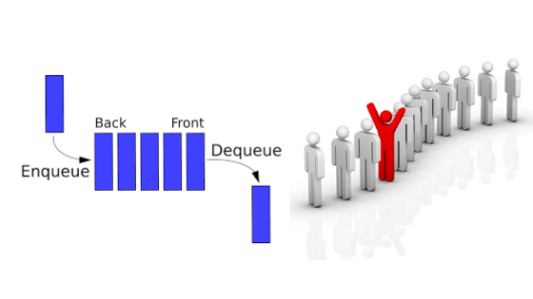

Basic Concepts:
- FIFO Principle: In a queue, the first element added is the first one to be removed. Think of it as a line of people waiting for a bus; the person who arrives first gets on the bus first.
- Enqueue: Adding an element to the end of the queue is known as enqueue.
- Dequeue: Removing an element from the front of the queue is known as dequeue.
- Peek: Looking at the element at the front of the queue without removing it.

Basic Operations on Stack in Java:

- Create a `Queue` object using the `LinkedList` class:

- Queue<String> queue = new LinkedList<>();

- Replace `String` with the data type you want to store in the queue.

- Enqueue (Add) elements to the queue: To add elements to the queue, you can use the `add` or `offer` method.
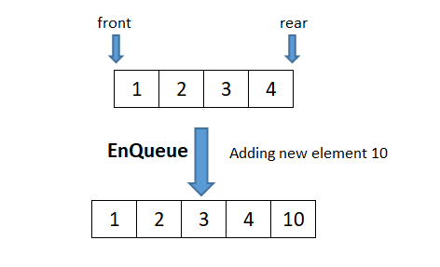
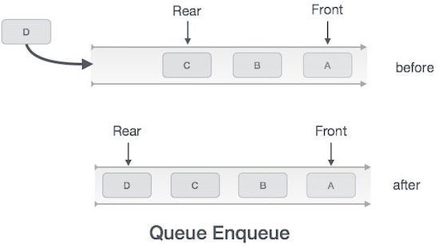
- Queue<String> queue = new LinkedList<>();
- queue.add("Item 1");
- queue.offer("Item 2");
- queue.add("Item 3");

Both `add` and `offer` methods will add elements to the back of the queue.

- Dequeue (Remove) elements from the queue: To remove elements from the front of the queue, you can use the `poll` or `remove` method. These methods not only remove the element but also return it.

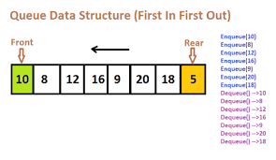
Queue<String> queue = new LinkedList<>();
String removedItem = queue.poll();

- The `poll` method returns `null` if the queue is empty, while the `remove` method throws a `NoSuchElementException` if the queue is empty. You can check if the queue is empty before dequeuing to avoid exceptions.

if (!queue.isEmpty()) {
String removedItem = queue.remove();
}

- Peek (Access) the front element of the queue: To access the front element of the queue without removing it, you can use the `peek` method.

Queue<String> queue = new LinkedList<>();
String frontItem = queue.peek();

The `peek` method returns `null` if the queue is empty.

- Check if the queue is empty: To check if the queue is empty, you can use the `isEmpty` method.

Queue<String> queue = new LinkedList<>();
boolean isEmpty = queue.isEmpty();

- Get the size of the queue: To get the number of elements in the queue, you can use the `size` method.

Queue<String> queue = new LinkedList<>();
int queueSize = queue.size();

Implementation Of a Queue Data Structure in Java using a Linked List:

class Node {
int data;
Node next;

public Node(int data) {
this.data = data;
this.next = null;
}
}

public class Queue {
private Node front; // points to the front of the queue
private Node rear; // points to the rear of the queue

public Queue() {
front = rear = null;
}

// Method to check if the queue is empty
public boolean isEmpty() {
return front == null;
}

// Method to enqueue (add) an element to the queue
public void enqueue(int data) {
Node newNode = new Node(data);
if (rear == null) {
front = rear = newNode;
} else {
rear.next = newNode;
rear = newNode;
}
}

// Method to dequeue (remove) an element from the queue
public int dequeue() {
if (isEmpty()) {
throw new IllegalStateException("Queue is empty");
}
int data = front.data;
front = front.next;
if (front == null) {
rear = null;
}
return data;
}

// Method to get the front element of the queue
public int front() {
if (isEmpty()) {
throw new IllegalStateException("Queue is empty");
}
return front.data;
}

// Method to get the size of the queue
public int size() {
int size = 0;
Node current = front;
while (current != null) {
size++;
current = current.next;
}
return size;
}

// Method to print the queue
public void display() {
Node current = front;
while (current != null) {
System.out.print(current.data + " ");
current = current.next;
}
System.out.println();
}
}

public class Main {
public static void main(String[] args) {
Queue queue = new Queue();

queue.enqueue(1);
queue.enqueue(2);
queue.enqueue(3);

System.out.println("Queue elements:");
queue.display();

System.out.println("Front element: " + queue.front());
System.out.println("Queue size: " + queue.size());

queue.dequeue();
System.out.println("Dequeued one element.");

System.out.println("Queue elements after dequeue:");
queue.display();
}
}

Time Complexity:

Operation | Time Complexity
Enqueue (Add) | O(1)
Dequeue (Remove) | O(1)
Front (Peek) | O(1)
IsEmpty | O(1)
Size | O(1)

Applications of Queues in Java:

1. Task Scheduling: Queues are commonly used for scheduling tasks or jobs. For example, in a multi-threaded application, you can use a queue to manage a pool of tasks that need to be executed.

2. Breadth-First Search (BFS): In graph algorithms like BFS, a queue is used to maintain the order in which nodes are visited. This ensures that you explore all nodes at a given depth before moving to the next depth level.

3. Print Queue: In a printer management system, print jobs are usually stored in a queue. The printer processes the jobs in the order they were added to the queue.

4. Buffering: Queues are used in buffering scenarios, such as in the production and consumption of data. For example, a producer can add data to the queue, and a consumer can remove data from it.

5. Resource Allocation: In scenarios where multiple processes or threads are contending for resources, a queue can be used to manage access to these resources fairly.

Advantages of Queues:

1. Simple and Predictable Behaviour: Queues have a straightforward behaviour where the first element added is the first one to be removed. This simplicity makes them easy to use and understand.

2. Efficient for FIFO Operations: Queues are efficient for adding elements to the back (enqueue) and removing elements from the front (dequeue) in O(1) time complexity for most implementations like `LinkedList` and `Array Deque`.

3. Data Buffering: They are excellent for buffering data between producers and consumers, ensuring data is processed in the correct order.

4. Task Management: Queues are valuable for managing tasks in multi-threaded applications, ensuring tasks are executed in a controlled and sequential manner.

Disadvantages of Queues:
1. Limited Access: Unlike arrays or lists, queues provide limited access to their elements. You can only access the front and back elements efficiently. Accessing elements in the middle of the queue requires dequeuing elements in front of them.

2. Fixed Size: Some queue implementations, like arrays, have a fixed size. This can be a limitation when dealing with dynamic data where the size of the queue needs to grow or shrink dynamically.

3. Overhead: Implementing a queue using certain data structures (e.g., linked list) may have overhead in terms of memory usage compared to simpler data structures like arrays.

4. Concurrency Challenges: When used in multi-threaded environments, queues may require additional synchronization mechanisms to ensure thread safety, which can add complexity to the code.

Tree Data Structure

A tree data structure is a widely used hierarchical data structure in computer science and mathematics. It resembles a real-life tree with a root at the top and branches spreading outwards. In a tree, each element is called a node, and nodes are connected by edges or branches. Here are some key concepts and terms associated with trees:

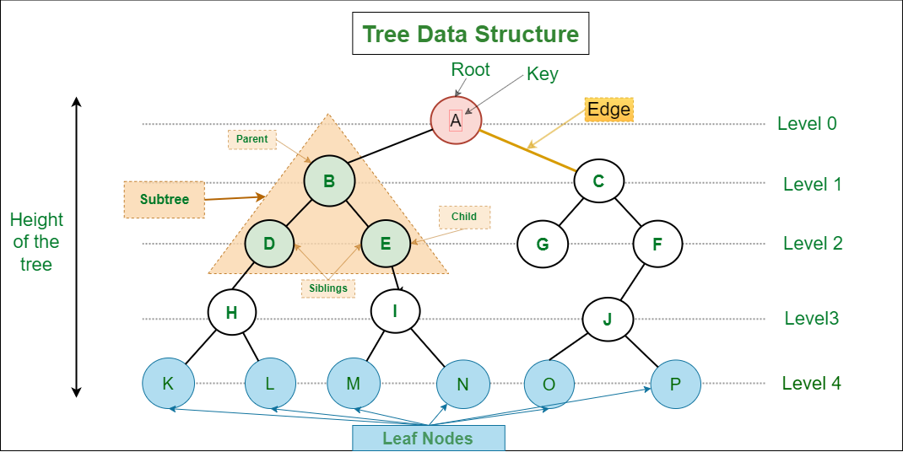

1. Node: Each element in a tree is called a node. Nodes can store data or values relevant to the application. They are connected to other nodes using edges.

2. Root: The root is the topmost node in a tree and serves as the starting point for traversal. It has no parent node.

3. Child: A node directly connected to another node (parent node) is called its child.

4. Parent: A node that has one or more child nodes connected to it is called a parent node.

5. Siblings: Nodes that share the same parent node are called siblings.

6. Leaf: A leaf is a node that has no children, meaning it is at the bottom of the tree structure.

7. Level: The level of a node is its distance from the root. The root node is at level 0, and its immediate children are at level 1, and so on.

8. Subtree: A subtree is a smaller tree within a larger tree, formed by selecting a node and all its descendants.

9. Height (Depth): The height or depth of a tree is the maximum level of any node in the tree. It represents the length of the longest path from the root to a leaf.

10. Binary Tree: A binary tree is a special type of tree in which each node has at most two children, typically referred to as the left child and the right child.

11. Binary Search Tree (BST): A binary search tree is a binary tree with the property that the left child of a node contains values less than the node's value, and the right child contains values greater than the node's value. This property allows for efficient searching, insertion, and deletion of elements.

12. Balanced Tree: A balanced tree is a tree in which the height of the left and right subtrees of any node differs by at most one. Common balanced tree types include AVL trees and Red-Black trees.

13. Tree Traversal: Tree traversal refers to the process of visiting all the nodes in a tree in a specific order. Common traversal methods include in-order, pre-order, post-order, and level-order traversal.

Introduction of Binary Tree Data Structure:

A binary tree is a hierarchical data structure that consists of nodes connected by edges. Each node in a binary tree has at most two children, which are referred to as the left child and the right child. These children themselves can be binary trees, making it a recursive data structure.

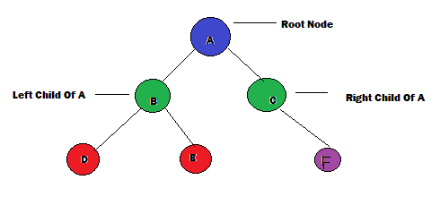

Basic Terminology of Binary Tree:

- Node: Each element in a binary tree is called a node. A node contains a value or data and can have references (pointers) to its left and right children.

class TreeNode {
int data;
TreeNode left;
TreeNode right;

public TreeNode(int data) {
this.data = data;
this.left = null;
this.right = null;
}
}
- Root: The topmost node in a binary tree is called the root. It is the starting point for traversing the tree.

- Parent: A node in a binary tree may have one or two child nodes. The node from which the child nodes originate is called the parent node.

- Child: A node in a binary tree may have zero, one, or two child nodes. These child nodes are nodes that are connected to a parent node.

- Leaf: A leaf node is a node that has no children, meaning it is a node at the end of a branch in the tree.

- Subtree: A subtree is a binary tree formed by a node and all its descendants. It's essentially a smaller binary tree within the larger tree.

- Depth: The depth of a node in a binary tree is the length of the path from the root node to that node. The depth of the root node is 0.
- Height: The height of a binary tree is the length of the longest path from the root node to any leaf node. It represents the depth of the deepest leaf node.

Basic Operation on Binary Tree:

- Define a Node Class: You'll start by defining a class for the nodes of the binary tree. Each node should have a value and references to its left and right children (if they exist).

class Node {
int data;
Node left;
Node right;

public Node(int data) {
this.data = data;
this.left = null;
this.right = null;
}
}

- Create a Binary Tree: Let's create a simple binary tree with the following structure:

10
/ \
5 20
/ \
3 7

public class BinaryTree {
Node root;

public BinaryTree() {
root = null;
}
}

- Insert Elements: To insert elements into the binary tree, you'll typically have a method that takes a value and inserts it in the correct position based on binary search tree properties.

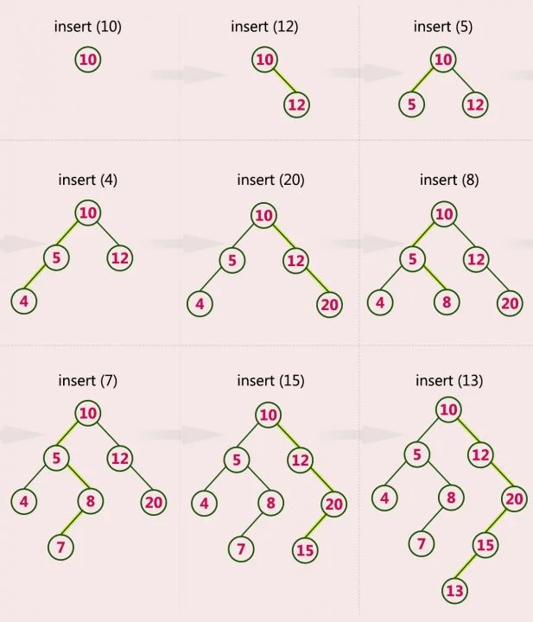
public void insert(int data) {
root = insertRecursive(root, data);
}

private Node insertRecursive(Node root, int data) {
if (root == null) {
root = new Node(data);
return root;
}

if (data < root.data) {
root.left = insertRecursive(root.left, data);
} else if (data > root.data) {
root.right = insertRecursive(root.right, data);
}

return root;
}
- Search for an Element: Searching for an element in a binary tree is typically done using a recursive approach.

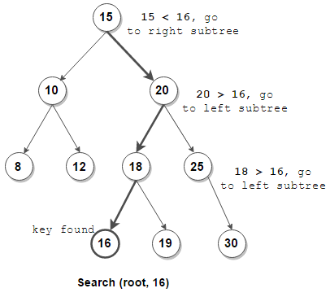

public boolean search(int data) {
return searchRecursive(root, data);
}

private boolean searchRecursive(Node root, int data) {
if (root == null) {
return false;
}

if (root.data == data) {
return true;
}

if (data < root.data) {
return searchRecursive(root.left, data);
} else {
return searchRecursive(root.right, data);
}
}
- Tree Traversal: You can traverse the binary tree using various methods like inorder, preorder, and postorder traversal. Here's an example of inorder traversal and remaining will cover in next chapter in details:

public void inorderTraversal(Node node) {
if (node != null) {
inorderTraversal(node.left);
System.out.print(node.data + " ");
inorderTraversal(node.right);
}
}

- Delete an Element (Optional): Deleting an element from a binary tree can be complex and involves multiple cases. It's an optional operation, but if you want to implement it, you can refer to resources specific to binary tree deletion in next chapter in details.

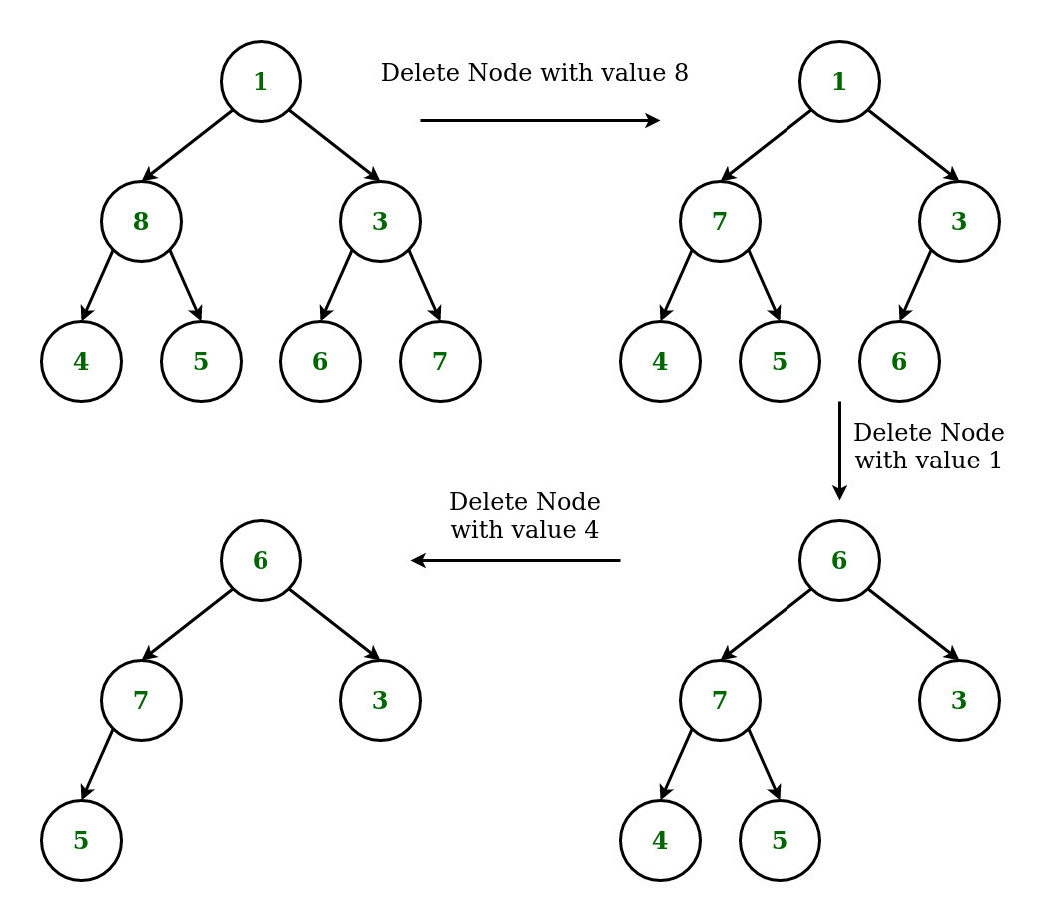

Auxiliary Operation On Binary Tree:

Auxiliary operations on a binary tree are additional operations that can be performed to enhance or extract information from the tree. These operations provide useful insights into the structure and content of the binary tree. Here are some common auxiliary operations on binary trees:

1. Height of the Binary Tree (or Depth): This operation calculates the height of the binary tree, which is the length of the longest path from the root to a leaf node.
It helps assess the balance of the tree and is useful for optimizing operations like searching and inserting.

public int getHeight(Node root) {
if (root == null) {
return 0;
}
int leftHeight = getHeight(root.left);
int rightHeight = getHeight(root.right);
return Math.max(leftHeight, rightHeight) + 1;
}

2. Size of the Binary Tree: The size operation calculates the total number of nodes in the binary tree.

public int getSize(Node root) {
if (root == null) {
return 0;
}
return 1 + getSize(root.left) + getSize(root.right);
}

3. Check if the Binary Tree is Balanced: This operation checks if the tree is balanced, meaning the height of the left and right subtrees of every node differs by at most one.

public boolean isBalanced(Node root) {
if (root == null) {
return true;
}
int leftHeight = getHeight(root.left);
int rightHeight = getHeight(root.right);
return Math.abs(leftHeight - rightHeight) <= 1 && isBalanced(root.left) && isBalanced(root.right);
}

4. Find the Deepest Node: This operation finds the node with the greatest depth (furthest from the root) in the binary tree.

public Node findDeepestNode(Node root) {
if (root == null) {
return null;
}
Queue<Node> queue = new LinkedList<>();
queue.offer(root);
Node deepestNode = null;
while (!queue.isEmpty()) {
deepestNode = queue.poll();
if (deepestNode.left != null) {
queue.offer(deepestNode.left);
}
if (deepestNode.right != null) {
queue.offer(deepestNode.right);
}
}
return deepestNode;
}

5. Find the Lowest Common Ancestor (LCA): Given two nodes in the binary tree, this operation finds their lowest common ancestor, which is the node furthest from the root that is an ancestor of both nodes.

public Node findLowestCommonAncestor(Node root, Node node1, Node node2) {
if (root == null || root == node1 || root == node2) {
return root;
}
Node left = findLowestCommonAncestor(root.left, node1, node2);
Node right = findLowestCommonAncestor(root.right, node1, node2);
if (left != null && right != null) {
return root;
}
return (left != null) ? left : right;
}

1.Tree traversals In Java (Depth First Search or DFS)

Tree traversals are techniques used to visit and process all the nodes in a binary tree. In binary trees, each node has at most two children: a left child and a right child. There are three common methods for tree traversal:

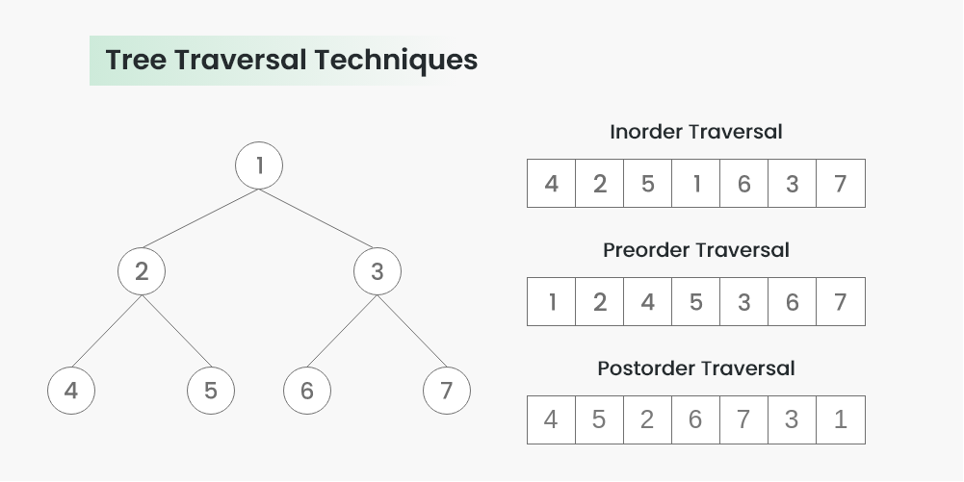

- Inorder Traversal.
- Preorder Traversal.
- Postorder Traversal.

Inorder Traversal: In inorder traversal, you visit the left subtree first, then the current node, and finally the right subtree.

Here's the Java code for inorder traversal using recursion:

class TreeNode {
int val;
TreeNode left;
TreeNode right;

TreeNode(int val) {
this.val = val;
this.left = null;
this.right = null;
}
}

void inorderTraversal(TreeNode root) {
if (root != null) {
inorderTraversal(root.left);
System.out.print(root.val + " ");
inorderTraversal(root.right);
}
}

To use this method, call `inorderTraversal(root)` where `root` is the root of your binary tree.

Preorder Traversal:

In preorder traversal, you visit the current node first, then the left subtree, and finally the right subtree.

Here's the Java code for preorder traversal using recursion:

void preorderTraversal(TreeNode root) {
if (root != null) {
System.out.print(root.val + " ");
preorderTraversal(root.left);
preorderTraversal(root.right);
}
}

To use this method, call `preorderTraversal(root)` where `root` is the root of your binary tree.

Postorder Traversal:

In postorder traversal, you visit the left subtree first, then the right subtree, and finally the current node.

Here's the Java code for postorder traversal using recursion:

void postorderTraversal(TreeNode root) {
if (root != null) {
postorderTraversal(root.left);
postorderTraversal(root.right);
System.out.print(root.val + " ");
}
}

To use this method, call `postorderTraversal(root)` where `root` is the root of your binary tree.

Example usage:

class TreeNode {
int val;
TreeNode left;
TreeNode right;

TreeNode(int val) {
this.val = val;
this.left = null;
this.right = null;
}
}

void inorderTraversal(TreeNode root) {
if (root != null) {
inorderTraversal(root.left);
System.out.print(root.val + " ");
inorderTraversal(root.right);
}
}

void preorderTraversal(TreeNode root) {
if (root != null) {
System.out.print(root.val + " ");
preorderTraversal(root.left);
preorderTraversal(root.right);
}
}

void postorderTraversal(TreeNode root) {
if (root != null) {
postorderTraversal(root.left);
postorderTraversal(root.right);
System.out.print(root.val + " ");
}
}

public static void main(String[] args) {
// Create a sample binary tree
TreeNode root = new TreeNode(1);
root.left = new TreeNode(2);
root.right = new TreeNode(3);
root.left.left = new TreeNode(4);
root.left.right = new TreeNode(5);

System.out.println("Inorder traversal:");
inorderTraversal(root);

System.out.println("\nPreorder traversal:");
preorderTraversal(root);

System.out.println("\nPostorder traversal:");
postorderTraversal(root);
}

Output:

Inorder traversal:
4 2 5 1 3

Preorder traversal:
1 2 4 5 3

Postorder traversal:
4 5 2 3 1

2. Level Order Traversal (Breadth First Search or BFS) of Binary Tree:
Level order traversal, also known as Breadth-First Search (BFS), is a tree traversal algorithm that visits all the nodes level by level, starting from the root and moving to the leftmost child, then to the right child, and so on. Here's a step-by-step implementation of level order traversal in a binary tree using Java:

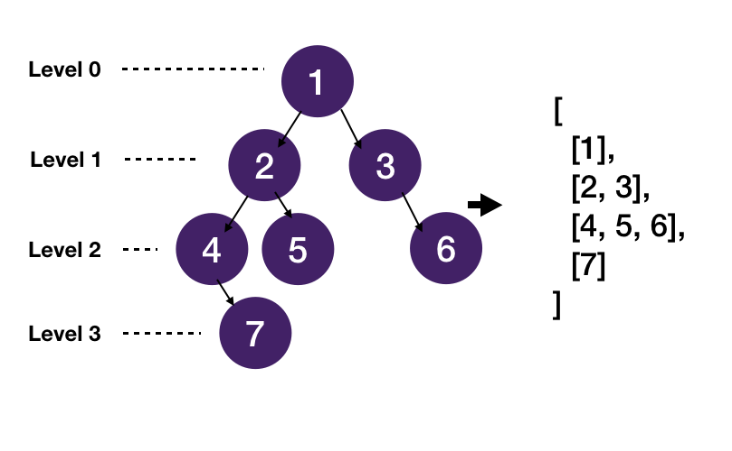

Algorithm:

- Create an empty queue (in this case, we're using a `LinkedList` as a queue).
- Start with the root node and add it to the queue.
- Begin a loop that continues until the queue is empty.
- Inside the loop, dequeue (remove) the front node from the queue and print its value.
- If the dequeued node has a left child, enqueue (add) the left child into the queue.
- If the dequeued node has a right child, enqueue the right child into the queue.
- Repeat steps 4-6 until the queue becomes empty, and you will have printed the nodes in level order.

Example:
class TreeNode {
int val;
TreeNode left;
TreeNode right;

TreeNode(int val) {
this.val = val;
this.left = null;
this.right = null;
}
}

void levelOrderTraversal(TreeNode root) {
if (root == null) {
return; // Return if the tree is empty
}

Queue<TreeNode> queue = new LinkedList<>();
queue.add(root);

while (!queue.isEmpty()) {
TreeNode current = queue.poll();
System.out.print(current.val + " ");

if (current.left != null) {
queue.add(current.left);
}

if (current.right != null) {
queue.add(current.right);
}
}
}

public static void main(String[] args) {
// Create a sample binary tree
TreeNode root = new TreeNode(1);
root.left = new TreeNode(2);
root.right = new TreeNode(3);
root.left.left = new TreeNode(4);
root.left.right = new TreeNode(5);

System.out.println("Level order traversal (BFS):");
levelOrderTraversal(root);
}

Output:
Level order traversal (BFS):
1 2 3 4 5

Maximum Depth or Height of given Binary Tree:

You can find the maximum depth or height of a binary tree in Java using a recursive approach. The maximum depth of a binary tree is the longest path from the root node to any leaf node. Here's a step-by-step implementation in Java:

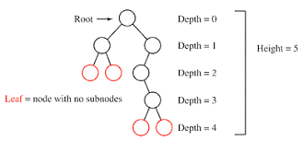

Algorithm:

1. If the root node is null (empty tree), return 0, as the depth of an empty tree is 0.

2. If the root node is not null, calculate the depth of the left subtree by calling `maxDepth(root.left)`.

3. Calculate the depth of the right subtree by calling `maxDepth(root.right)`.

4. Return the maximum depth between the left and right subtrees, plus 1 for the current node.

You can calculate the maximum depth using a recursive function:

int maxDepth(TreeNode root) {
if (root == null) {
return 0; // The depth of an empty tree is 0.
} else {
int leftDepth = maxDepth(root.left);
int rightDepth = maxDepth(root.right);

// Return the maximum depth among the left and right subtrees, plus 1 for the current node.
return Math.max(leftDepth, rightDepth) + 1;
}
}

Example usage:

class TreeNode {
int val;
TreeNode left;
TreeNode right;

TreeNode(int val) {
this.val = val;
this.left = null;
this.right = null;
}
}

int maxDepth(TreeNode root) {
if (root == null) {
return 0; // The depth of an empty tree is 0.
} else {
int leftDepth = maxDepth(root.left);
int rightDepth = maxDepth(root.right);

// Return the maximum depth among the left and right subtrees, plus 1 for the current node.
return Math.max(leftDepth, rightDepth) + 1;
}
}

public static void main(String[] args) {
// Create a sample binary tree
TreeNode root = new TreeNode(1);
root.left = new TreeNode(2);
root.right = new TreeNode(3);
root.left.left = new TreeNode(4);
root.left.right = new TreeNode(5);

int depth = maxDepth(root);
System.out.println("Maximum depth of the binary tree: " + depth);
}
```

Output:

Maximum depth of the binary tree: 3

In this example, the maximum depth of the binary tree is 3, as the longest path from the root to a leaf is `1 -> 2 -> 4`.

Time Complexity For Various Operations:

1. Binary Tree Operations:
- Insertion (Average Case): O(log n) - For balanced trees like AVL or Red-Black Trees.
- Insertion (Worst Case): O(n) - For a degenerate tree (skewed tree).
- Deletion: O(log n) - For balanced trees.
- Search (Average Case): O(log n) - For balanced trees.
- Search (Worst Case): O(n) - For a degenerate tree.

2. Binary Search Tree (BST) Operations (assuming a balanced BST):
- Insertion: O(log n)
- Deletion: O(log n)
- Search: O(log n)

3. AVL Tree Operations (self-balancing binary search tree):
- Insertion: O(log n)
- Deletion: O(log n)
- Search: O(log n)

4. Red-Black Tree Operations (another self-balancing binary search tree):
- Insertion: O(log n)
- Deletion: O(log n)
- Search: O(log n)

5. Binary Heap Operations (used in heapsort and priority queues):
- Insertion: O(log n)
- Deletion (extract minimum/maximum): O(log n)
- Build Heap: O(n) - Building a heap from an array.

6. Traversal Operations (In-order, Pre-order, Post-order):
- Time Complexity: O(n) - Since you visit all nodes in the tree once during traversal.

Operation | Average Case | Worst Case | Description
Insertion | O(log n) | O(n) | Add a new node to the binary tree.
Deletion | O(log n) | O(n) | Remove a node from the binary tree.
Search | O(log n) | O(n) | Find a node with a given key.
Minimum | O(log n) | O(n) | Find the minimum value in the tree.
Maximum | O(log n) | O(n) | Find the maximum value in the tree.
Preorder Traversal | O(n) | O(n) | Visit nodes in the order: root-left-right
Inorder Traversal | O(n) | O(n) | Visit nodes in the order: left-root-right
Postorder Traversal | O(n) | O(n) | Visit nodes in the order: left-right-root
Level Order Traversal | O(n) | O(n) | Visit nodes level by level, left to right

Type of Binary Tree:

1. Binary Search Tree (BST): A binary search tree is a binary tree with the following properties:
- Each node has a value.
- The left subtree of a node contains only nodes with values less than the node's value.
- The right subtree of a node contains only nodes with values greater than the node's value.
- Advantages: Efficient for searching, insertion, and deletion operations with an average time complexity of O(log n) when the tree is balanced.
- Disadvantages: If not properly balanced, it can degrade into a linked list, resulting in O(n) time complexity for operations.

2. Balanced Binary Trees:
AVL Tree:
- AVL tree (Adelson-Velsky and Landis tree) is a self-balancing binary search tree. It maintains balance by enforcing a balance factor (height difference between left and right subtrees) of at most 1 for each node.
- Ensures efficient O(log n) search, insertion, and deletion.

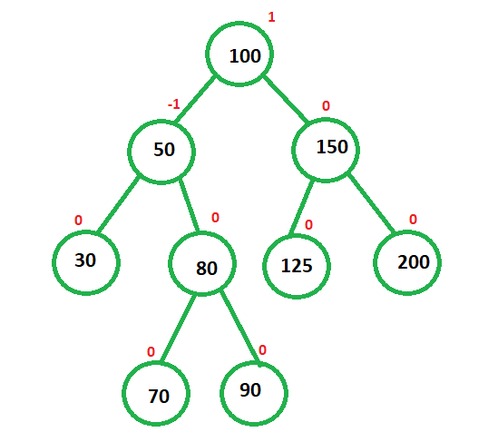

Red-Black Tree:
- A red-black tree is another self-balancing binary search tree where each node has a color (red or black). It follows specific rules to maintain balance.
- Offers efficient O(log n) operations.

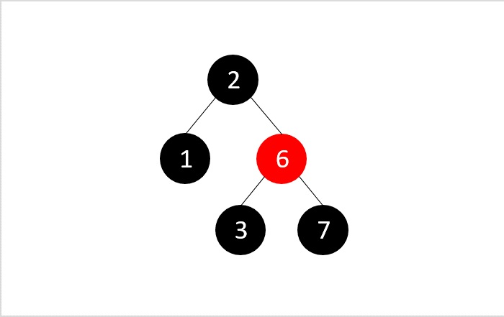

Splay Tree:
- A splay tree is a self-adjusting binary search tree. After each operation (search, insert, or delete), it rearranges nodes to bring frequently accessed nodes closer to the root.
- Provides amortized O(log n) time for operations.

3. Heap:
Min Heap and Max Heap:
- A heap is a specialized binary tree used to implement priority queues. In a min heap, the parent node has a smaller value than its children, while in a max heap, the parent node has a larger value.
- Heap operations like insert and extract-min/extract-max have time complexity of O(log n).

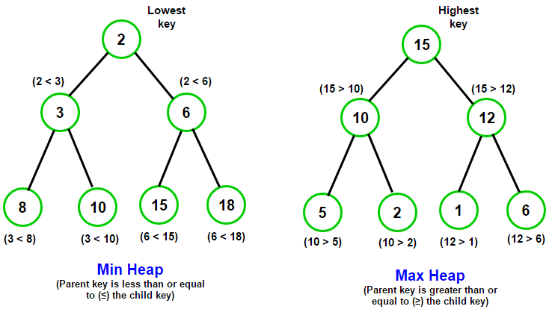

Binary Heap:
- A binary heap is a complete binary tree, making it efficient for storage. It is commonly used for heapsort and graph algorithms (e.g., Dijkstra's algorithm).

4. Binary Expression Tree:
- A binary expression tree is used to represent mathematical expressions in a tree structure, where operators are internal nodes, and operands are leaf nodes. It's used for evaluating expressions.

5. Binary Tree Traversal:
There are three common ways to traverse a binary tree:
- Inorder Traversal: Visits nodes in ascending order (for BSTs).
- Preorder Traversal: Visits the root before its children.
- Postorder Traversal: Visits the root after its children.

6. Full Binary Tree:
- In a full binary tree, every node has either 0 or 2 children. It's sometimes called a "proper binary tree."
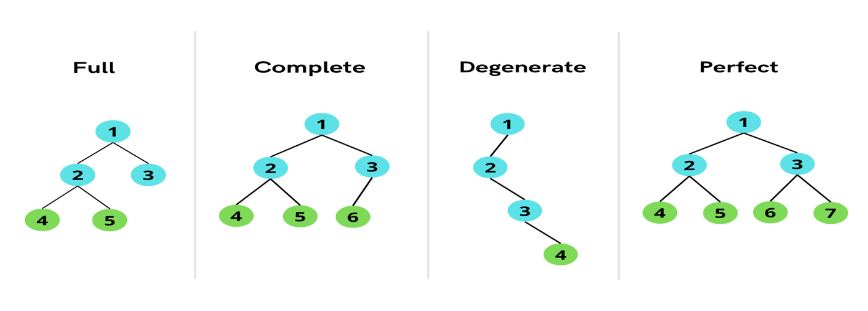

7. Complete Binary Tree:
- A complete binary tree is a binary tree in which all levels are completely filled, except possibly the last level, which is filled from left to right. It's used in heap data structures.

8. Perfect Binary Tree:
- In a perfect binary tree, all internal nodes have two children, and all leaf nodes are at the same level. This results in a balanced tree.

9. Degenerate (or Skewed) Binary Tree:
- A degenerate binary tree is essentially a linked list, where each node has only one child. It's highly unbalanced and can result from improper insertion order in a BST.

Application of Binary Trees:

1. Binary Search Trees (BST):
Binary search trees are binary trees that follow the property that for each node:
- All nodes in its left subtree have values less than the node's value.
- All nodes in its right subtree have values greater than the node's value.
BSTs are used for efficient searching, insertion, and deletion of elements. In Java, the `TreeMap` and `TreeSet` classes are implemented using BSTs.

2. Balanced Binary Trees (AVL Trees, Red-Black Trees):
These are self-balancing binary search trees that maintain a balance factor to ensure that the tree remains balanced. They are used in Java for implementing data structures like `TreeMap` and `TreeSet`. AVL trees and Red-Black trees ensure that the height of the tree remains logarithmic, providing efficient time complexities for operations.

3. Binary Heap:
A binary heap is a complete binary tree used for efficient implementation of priority queues. Java's `PriorityQueue` class is typically implemented using a binary heap. Binary heaps come in two forms: min-heap and max-heap, where the minimum or maximum element is at the root, respectively.

4. Expression Trees:
Binary trees can be used to represent expressions, such as arithmetic expressions, in a way that preserves their hierarchical structure. These expression trees can be evaluated, simplified, or transformed. For example, you can implement a calculator that parses an expression into an expression tree and then evaluates it.

5. Binary Tree Traversal:
Binary trees are often used to store hierarchical data like file systems or organizational structures. Traversing binary trees is essential for tasks like searching for specific elements, generating sorted output, or applying operations to all elements. Common traversal algorithms include in-order, pre-order, and post-order traversals.

6. Binary Search:
Binary search is a search algorithm that can be applied on sorted arrays or lists. You can implement binary search using a binary tree structure to efficiently find a specific element in logarithmic time complexity.

7. Huffman Coding:
Huffman coding is a compression algorithm that uses binary trees to represent characters based on their frequencies in a text. Java can be used to implement Huffman coding for data compression and decompression.

8. Binary Tree Serialization/Deserialization:
Binary trees can be serialized into a format that can be stored or transmitted and later deserialized to recreate the original tree. This is useful for saving and loading complex data structures, like configuration settings or game states.

9. Binary Search Tree Operations:
Binary trees can be used for various data storage and retrieval tasks like maintaining ordered collections, finding the closest neighbor to a given value, and checking for the existence of a specific element.

10. Graph Algorithms:
Binary trees can be viewed as a special case of graphs. Algorithms for tree traversal, shortest path finding, and cycle detection can be applied to binary trees when they are used to represent hierarchical relationships.

Advantages of Binary Trees:

1. Efficient Searching: Binary trees provide efficient searching due to their hierarchical structure. Binary Search Trees, in particular, offer fast lookup times.

2. Efficient Insertion and Deletion: Binary trees allow for efficient insertion and deletion operations, especially when maintaining balance.

3. Ordered Data Storage: Binary Search Trees store data in an ordered manner, making it easy to retrieve data in sorted order.

4. Simple to Implement: Binary trees are relatively simple to implement compared to more complex data structures like B-trees.

5. Versatility: Binary trees can be adapted for various purposes, from searching and sorting to representing hierarchical relationships.

Disadvantages of Binary Trees:

1. Unbalanced Trees: If not properly balanced, binary trees can degenerate into a linked list, leading to inefficient operations. This is a significant drawback of plain binary trees, which led to the development of self-balancing variants like AVL and Red-Black trees.

2. Limited Search Performance: Binary trees can become inefficient when dealing with skewed or unbalanced data, causing search times to approach O(n) in the worst case.

3. Storage Overhead: Binary trees can have a higher storage overhead compared to other data structures like arrays or linked lists due to the need to store additional pointers for child nodes.

4. Complexity of Balancing: Self-balancing binary trees require complex algorithms to maintain balance, which can add complexity to their implementation.

5. Limited Applications: While binary trees have various applications, they are not always the best choice for every problem. Other data structures like hash tables or arrays may be more suitable in some cases.

Graph Data Structure:

